Project Design Phase-II
Technology Stack (Architecture & Stack)

Date | 14 July 2026
Team ID
Project Name | Online complaint
Maximum Marks | 4 Marks

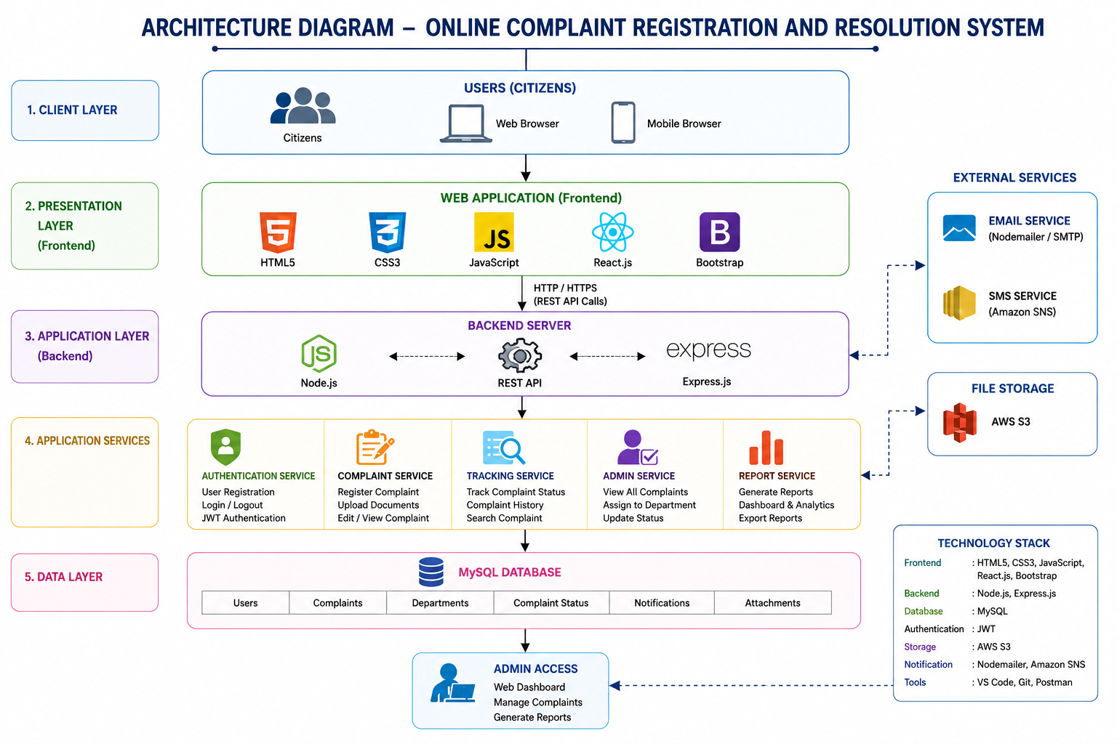

Technology Stack
Layer | Technology | Purpose
Frontend | HTML5 | Structure of web pages
Frontend | CSS3 | Styling and responsive design
Frontend | Bootstrap 5 | Responsive UI components
Frontend | JavaScript (ES6) | Client-side scripting and validation
Frontend | React.js | Interactive user interface
Backend | Node.js | Server-side runtime environment
Backend | Express.js | REST API development
Database | MySQL | Store users, complaints, and complaint status
Authentication | JWT / Firebase Authentication | Secure user authentication and authorization
Cloud Storage | AWS S3 | Store uploaded complaint images and documents
Notification | Nodemailer / Amazon SNS | Email notifications for complaint updates
API Testing | Postman | API development and testing
Version Control | Git & GitHub | Source code management
IDE | Visual Studio Code | Application development
Deployment | Nginx / Apache | Web server and application hosting

Technology Stack Layers
Layer | Tools Used
Client Layer | HTML5, CSS3, Bootstrap, JavaScript, React.js
Application Layer | Node.js, Express.js
Authentication Layer | JWT / Firebase Authentication
Database Layer | MySQL
Storage Layer | AWS S3
Notification Layer | Nodemailer / Amazon SNS
Development Tools | VS Code, Git, GitHub, Postman
Deployment Layer | Nginx / Apache

Architecture Overview
Component | Technology Used | Function
User Interface | React.js, HTML5, CSS3, Bootstrap | Complaint registration and tracking interface
Business Logic | Node.js, Express.js | Processes user requests and complaint workflows
Authentication | JWT / Firebase | Secure login and user authorization
Database | MySQL | Stores user accounts, complaints, and status updates
File Management | AWS S3 | Stores complaint attachments securely
Notification Service | Nodemailer / Amazon SNS | Sends email notifications when complaint status changes
Admin Panel | React.js + Express.js | Complaint management, assignment, and reporting
API Testing | Postman | Tests REST APIs
Source Control | Git & GitHub | Version control and collaboration

Architecture Flow
- Citizen accesses the application through a web browser.
- React.js frontend collects complaint details from the user.
- The frontend sends requests to the Node.js + Express.js REST API.
- The backend validates user credentials using JWT/Firebase Authentication.
- Complaint data is stored in the MySQL Database.
- Uploaded files (images/documents) are stored in AWS S3.
- The Admin Dashboard allows administrators to review, assign, and resolve complaints.
- The Notification Service sends email alerts whenever the complaint status changes.
- Citizens can log in anytime to track the complaint status until it is resolved.
This technology stack is well-suited for an Online Complaint Registration and Resolution System and follows a modern three-tier web application architecture.

